* Due Date – See Class Schedule *

* Use your own words to answer the questions, do not cut and paste from another source, that is cheating *

1. (10 points) Consider the following parse table. Parse (means show the Shift-Reduce trace, not a Parse Tree) the input “abaab” and determine if it is accepted in the grammar

1) S –> XX

2) X –> aX

3) X –> b

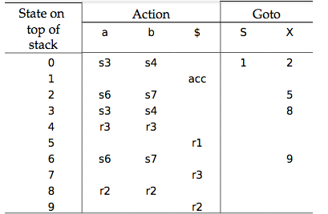

|  |  |  |  |  |  |
| --- | --- | --- | --- | --- | --- |
|  | Stack | Symbol | Input | Algorithm | Action |
| (1) | 0 |  | abaab$ | Action[0,a]=s3 | shift |
| (2) | 0 3 | a | baab$ | Action[3,b] | shift |
| (4) | 0 3 4 | ab | aab$ | Action[4,a]=r3  GOTO[3,X]=8 | reduce by  X –> b |
| (5) | 0 3 8 | aX | aab$ | Action[8,a]=r2  GOTO[0,X]=2 | Reduce by X –> aX |
| (6) | 0 2 | X | aab$ | Action[2,a]=s6 | shift |
| (7) | 0 2 6 | Xa | ab$ | Action[6,a]=s6 | shift |
| (8) | 0 2 6 6 | Xaa | b$ | Action[6,b]=s7 | Shift |
| (9) | 0 2 6 6 7 | Xaab | $ | Action[7,$]=r3  GOTO[6,X]=9 | Reduce by  X –> b |
| (10) | 0 2 6 6 9 | XaaX | $ | Action[9,$]=r2  GOTO[6,X]=9 | Reduce by X –> aX |
| (11) | 0 2 6 9 | XaX | $ | Action[9,$]=r2  GOTO[2,X]=5 | Reduce by X –> aX |
| (12) | 0 2 5 | XX | $ | Action[5,$]=r1  GOTO[0,S]=1 | Reduce by  S –> XX |
| (13) | 0 1 | S | $ | Action[1,$]=acc | accept |

Input string “abaab” is accepted